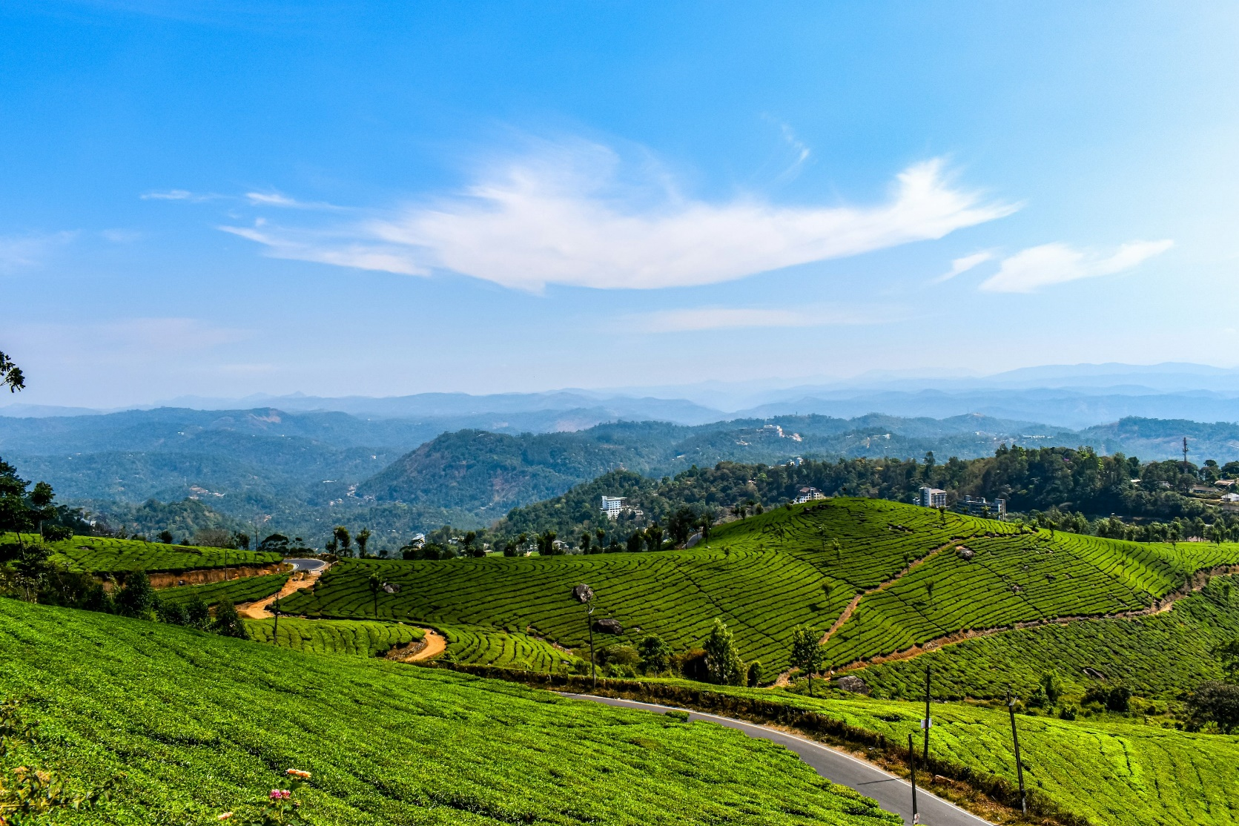
MUNNAR TOUR
ITINERARY PUBLISHED:
03 SEP’26 | DAY 01 | ARRIVE COCHIN – MUNNAR (126Kms, 03Hrs drive)
Meeting and assistance upon arrival at Cochin airport and drive to hotel. Upon arrival check in at hotel.

Overnight stay in Munnar

04 SEP’26 | DAY 02: | MUNNAR
Full day Munnar sightseeing tour Munnar.

Overnight stay in Munnar

05 SEP’26 | DAY 03: | MUNNAR – COCHIN (126Kms, 03Hrs drive)
Morning after breakfast drop at Hotel in Cochin

TOUR COST:
UNIT | NETT TOTAL COST
Cost for transportation for 03 days from Cochin to Cochin | INR 17,000/-

Our prices include:
- Transportation for 03 days from Cochin to Cochin by Toyota Innova Crysta
- Sightseeing in Munnar

Our prices do not include:

Accomodation

Entrance fees to monuments

Services of English speaking guide

Tips for guides (at the client's discretion).

Travel and cancellation insurance (optional).

Beverages.

Any services not mentioned as included, including personal extras such as telephone calls, laundry

service, etc.

5% GST

